TOPIC 5 : GREEDY
NAME: LAKSHMI DEVI.J
REG.NO: 192524300
1. There are 3n piles of coins of varying size, you and your friends will take piles of coins as follows: In each step, you will choose any 3 piles of coins (not necessarily consecutive). Of your choice, Alice will pick the pile with the maximum number of coins. You will pick the next pile with the maximum number of coins. Your friend Bob will pick the last pile. Repeat until there are no more piles of coins. Given an array of integers piles where piles[i] is the number of coins in the ith pile. Return the maximum number of coins that you can have.
Aim
To find the maximum number of coins you can collect when every three piles are selected, Alice takes the largest, you take the second largest, and Bob takes the smallest.

Algorithm
- Sort the piles in ascending order.
- Alice always gets the largest remaining pile.
- Bob gets the smallest remaining pile.
- You get the second-largest remaining pile.
- Repeat until all piles are used.
- Add your selected piles and return the total.

Python Program
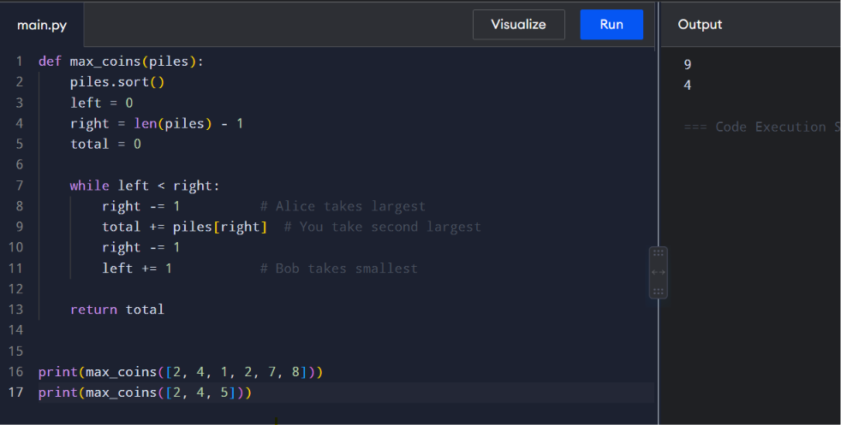
Time Complexity: O(n log n)
Space Complexity: O(1)

2. You are given a 0-indexed integer array coins, representing the values of the coins available, and an integer target. An integer x is obtainable if there exists a subsequence of coins that sums to x. Return the minimum number of coins of any value that need to be added to the array so that every integer in the range [1, target] is obtainable. A subsequence of an array is a new non-empty array that is formed from the original array by deleting some (possibly none) of the elements without disturbing the relative positions of the remaining elements.
Aim
To find the minimum number of coins that must be added so that every value from 1 to target can be obtained.
Algorithm
- Sort the coins.
- Maintain reachable, the smallest value that cannot currently be formed.
- If the next coin is at most reachable, extend the reachable range.
- Otherwise, add a new coin having value reachable.
- Continue until reachable > target.
- Return the number of added coins.
Python Program
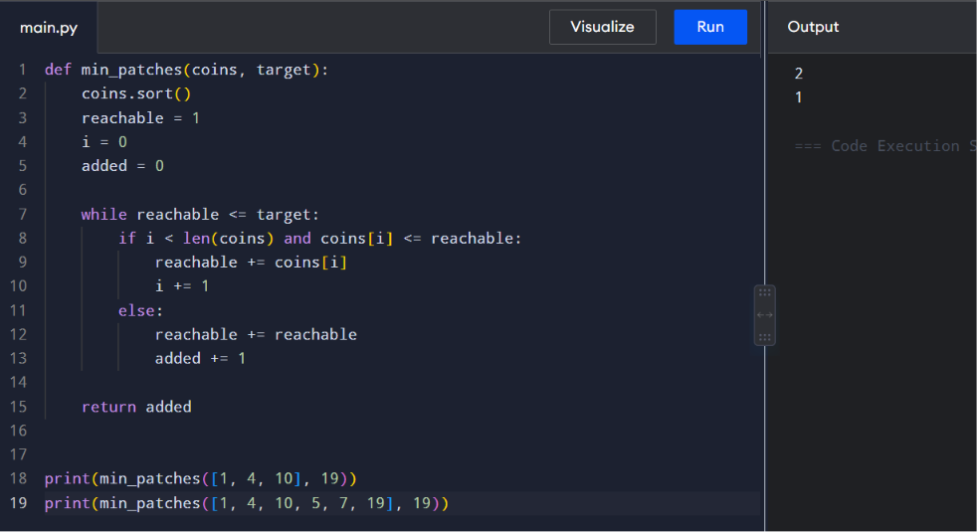
Complexity
- Time: O(n log n)
- Space: O(1)

3. You are given an integer array jobs, where jobs[i] is the amount of time it takes to complete the ith job. There are k workers that you can assign jobs to. Each job should be assigned to exactly one worker. The working time of a worker is the sum of the time it takes to complete all jobs assigned to them. Your goal is to devise an optimal assignment such that the maximum working time of any worker is minimized. Return the minimum possible maximum working time of any assignment.
Aim
To assign jobs to k workers such that the maximum working time of any worker is minimized.
Algorithm
- Sort jobs in decreasing order.
- Maintain the total working time of every worker.
- Assign each job to the worker having the smallest current workload.
- Try all possible assignments using backtracking.
- Keep track of the minimum possible maximum workload.
- Return the minimum maximum workload.
Python Program
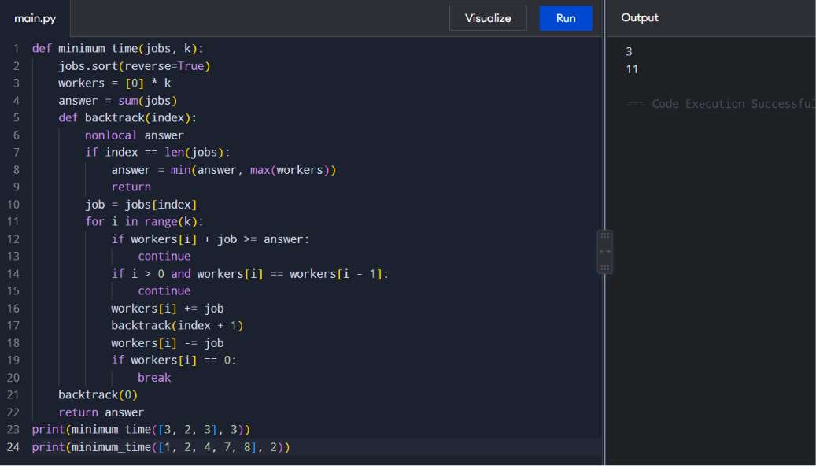

Complexity
- Time: O(kⁿ)
- Space: O(n + k)

4. We have n jobs, where every job is scheduled to be done from startTime[i] to endTime[i], obtaining a profit of profit[i]. You're given the startTime, endTime and profit arrays, return the maximum profit you can take such that there are no two jobs in the subset with overlapping time range. If you choose a job that ends at time X you will be able to start another job that starts at time X.
Aim
To select non-overlapping jobs such that the total profit is maximum.
Algorithm
- Combine start time, end time and profit for each job.
- Sort jobs according to their end times.
- For every job, find the last job that finishes before or exactly when the current job starts.
- Calculate:
  - Profit by taking current job.
  - Profit by skipping current job.
- Store the maximum profit using dynamic programming.
- Return the final maximum profit.
Python Program
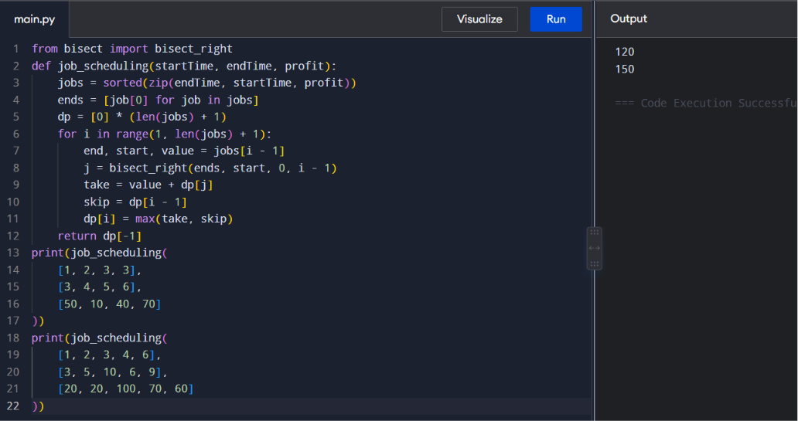
Complexity
- Time: O(n log n)
- Space: O(n)

5. Given a graph represented by an adjacency matrix, implement Dijkstra's Algorithm to find the shortest path from a given source vertex to all other vertices in the graph. The graph is represented as an adjacency matrix where graph[i][j] denote the weight of the edge from vertex i to vertex j. If there is no edge between vertices i and j, the value is Infinity (or a very large number).
Aim
To find the shortest distance from a source vertex to every other vertex using Dijkstra's algorithm.
Algorithm
- Initialize all distances to infinity.
- Set the source distance to 0.
- Select the unvisited vertex having the smallest distance.
- Mark it as visited.
- Update the distances of its adjacent vertices.
- Repeat until all vertices are processed.
- Print the shortest distances.
Python Program
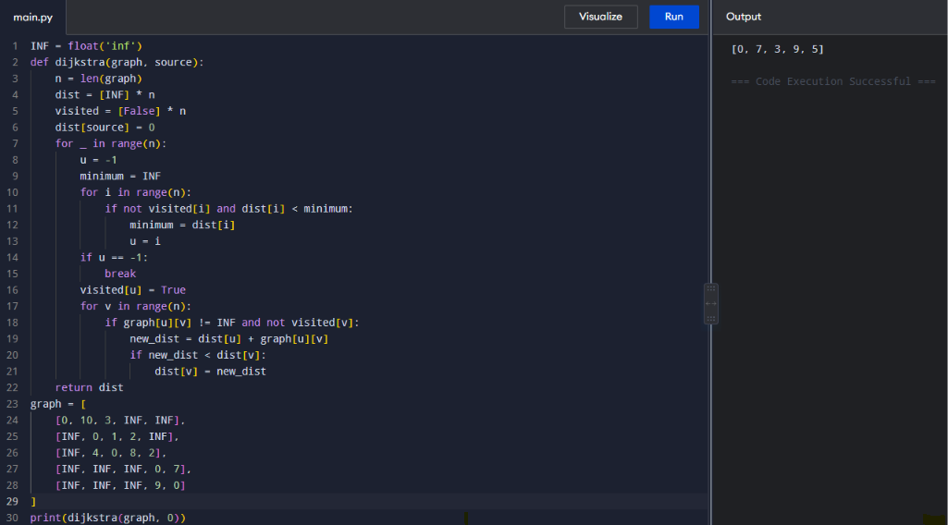
Complexity
- Time: O(V²)
- Space: O(V)
6. Given a graph represented by an edge list, implement Dijkstra's Algorithm to find the shortest path from a given source vertex to a target vertex. The graph is represented as a list of edges where each edge is a tuple (u, v, w) representing an edge from vertex u to vertex v with weight w.
Aim
To find the shortest path between a source and target vertex using Dijkstra's algorithm with an edge-list representation.
Algorithm
- Convert the edge list into an adjacency list.
- Set the source distance to 0.
- Insert the source into a priority queue.
- Remove the vertex having the smallest distance.
- Relax all its neighboring edges.
- Continue until the target is reached or the queue becomes empty.
- Return the shortest distance.
Python Program
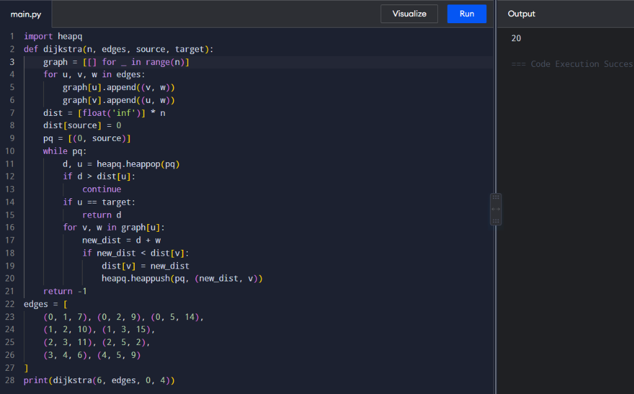
Complexity
- Time: O((V + E) log V)
- Space: O(V + E)
7. Given a set of characters and their corresponding frequencies, construct the Huffman Tree and generate the Huffman Codes for each character.

Aim
To construct a Huffman Tree and generate Huffman codes for the given characters and frequencies.

Algorithm
- Create a leaf node for every character.
- Insert all nodes into a min-priority queue according to frequency.
- Remove the two nodes having the smallest frequencies.
- Create a new node whose frequency is their sum.
- Insert the new node back into the queue.
- Repeat until only one node remains.
- Traverse the tree:
  - Left edge → 0
  - Right edge → 1
- The generated paths are the Huffman codes.

Python Program
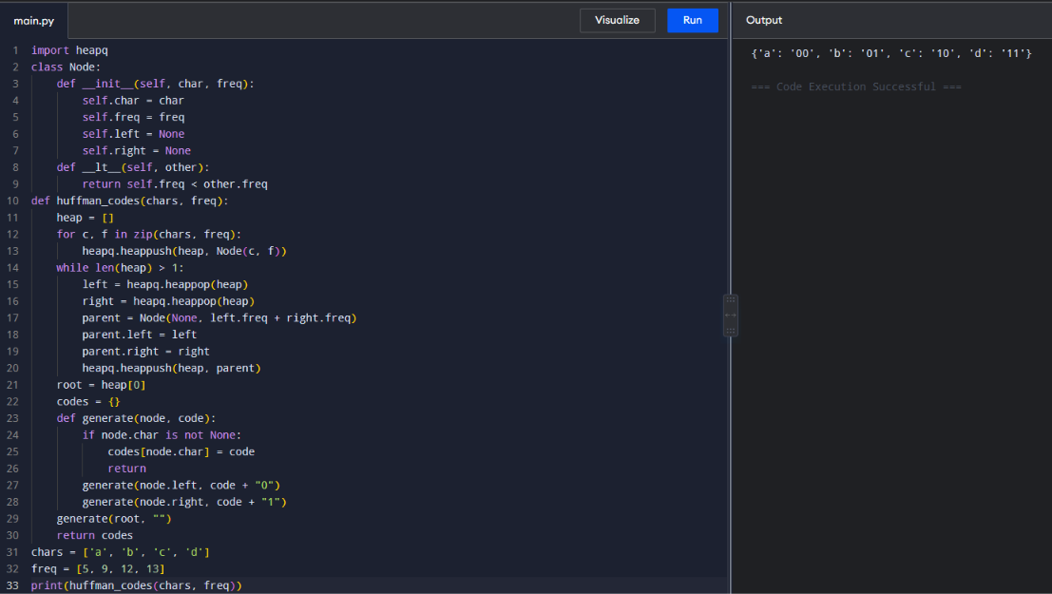
Complexity
- Time: O(n log n)
- Space: O(n)
8. Given a Huffman Tree and a Huffman encoded string, decode the string to get the original message.
Aim
To decode a Huffman-encoded binary string using the Huffman Tree.
Algorithm
- Start from the root of the Huffman Tree.
- Read the encoded string one bit at a time.
- If the bit is 0, move to the left child.
- If the bit is 1, move to the right child.
- When a leaf node is reached, append its character to the result.
- Return to the root and continue.
- Repeat until all bits are processed.
Python Program
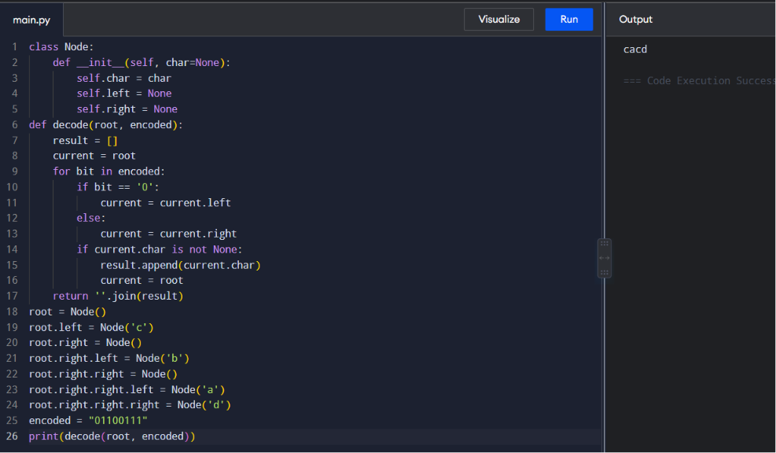
Complexity
- Time: O(m)
- Space: O(n)
9. Given a list of item weights and the maximum capacity of a container, determine the maximum weight that can be loaded into the container using a greedy approach. The greedy approach should prioritize loading heavier items first until the container reaches its capacity.
Aim
To maximize the weight loaded into a container without exceeding its capacity using a greedy strategy.
Algorithm
- Sort the weights in descending order.
- Start with total weight 0.
- Select the largest item that can fit.
- Add it to the container.
- Continue until no remaining item can fit.
- Return the total weight.
Python Program
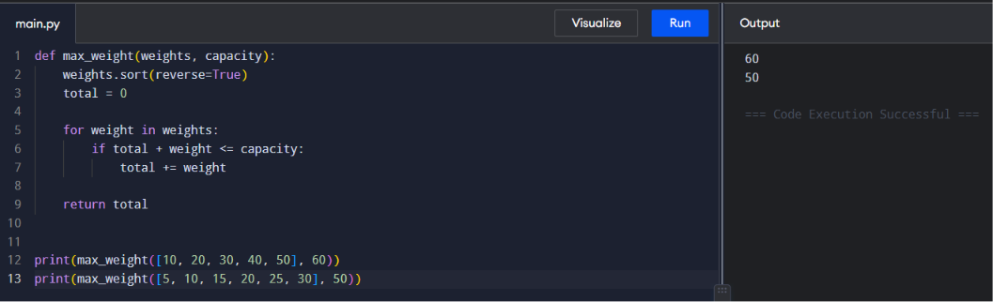
Complexity
- Time: O(n log n)
- Space: O(1)
10. Given a list of item weights and a maximum capacity for each container, determine the minimum number of containers required to load all items using a greedy approach. The greedy approach should prioritize loading items into the current container until it is full before moving to the next container.
Aim
To find the minimum number of containers required to load all items using the given greedy strategy.
Algorithm
- Sort the weights.
- Start with an empty container.
- Add items to the current container while they fit.
- When the next item does not fit, open a new container.
- Continue until all items are loaded.
- Return the number of containers.
Python Program
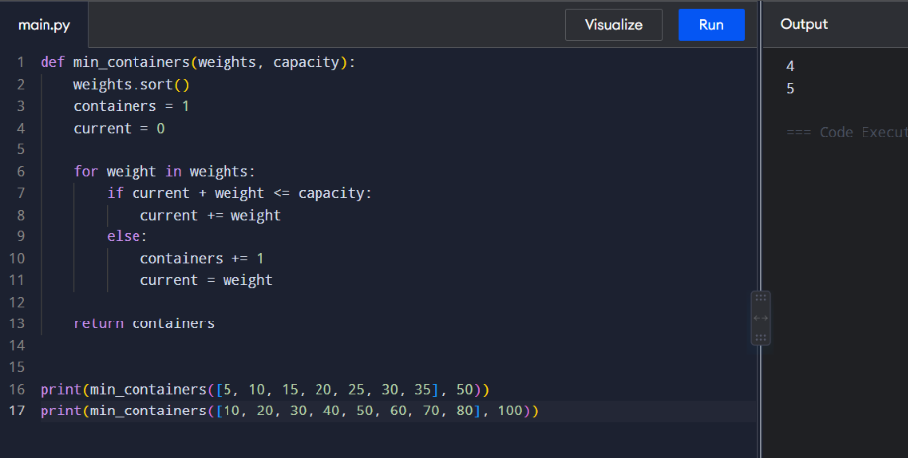
Complexity
- Time: O(n log n)
- Space: O(1)
11. Given a graph represented by an edge list, implement Kruskal's Algorithm to find the Minimum Spanning Tree (MST) and its total weight.
Aim
To find the Minimum Spanning Tree (MST) of a weighted graph using Kruskal's algorithm.
Algorithm
- Sort all edges in increasing order of weight.
- Create a separate set for every vertex.
- Select the smallest edge.
- Check whether adding the edge creates a cycle.
- If it does not create a cycle, add it to the MST.
- Merge the sets of the two vertices.
- Continue until V-1 edges are selected.
- Calculate and display the total weight.
Python Program
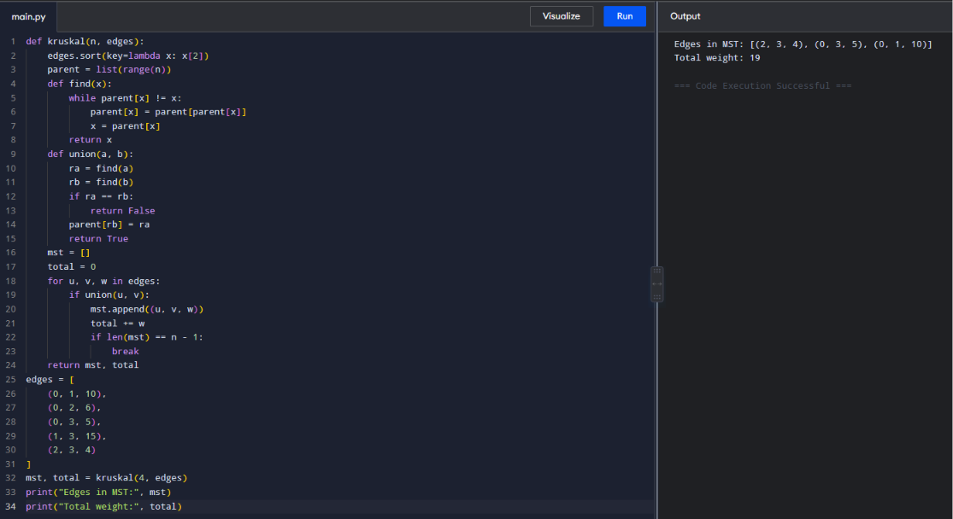
Complexity
- Time: O(E log E)
- Space: O(V)
12. Given a graph with weights and a potential Minimum Spanning Tree (MST),verify if the given MST is unique. If it is not unique, provide another possible MST.
Aim
To determine whether a given Minimum Spanning Tree is unique and, if it is not unique, find another possible MST.
Algorithm
- Calculate the MST using Kruskal's algorithm.
- Compare its total weight with the given MST.
- For every edge in the given MST:
  - Temporarily remove that edge.
  - Find another MST using the remaining edges.
- If another MST with the same total weight is found, the MST is not unique.
- Otherwise, the given MST is unique.
- Display another MST when one exists.
Python Program
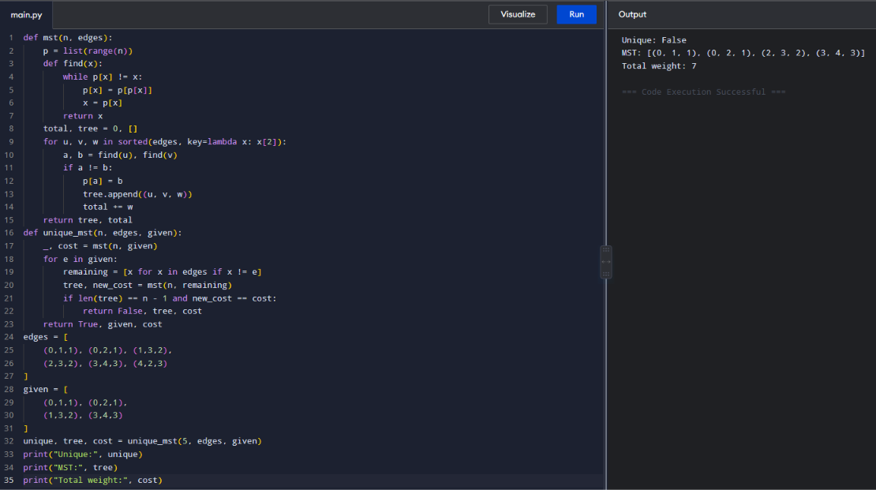
Complexity
- Time: O(E² log E)
- Space: O(V + E)

